**DAILY ONLINE ACTIVITIES SUMMARY**

|  |  |  |  |  |  |  |  |  |
| --- | --- | --- | --- | --- | --- | --- | --- | --- |
| **Date:** | **28-06-2020** | | | | | **Name:** | **Deeksha D Poojary** | |
| **Sem & Sec** | **VIII Semester & A Section** | | | | | **USN:** | **4AL16CS026** | |
| **Online Test Summary** | | | | | | | | |
| **Subject** | | **-** | | | | | | |
| **Max. Marks** | | **-** | | **Score** | | | **-** | |
| **Certification Course Summary** | | | | | | | | |
| **Course** | **Introduction to Amazon Elastic Compute Cloud (EC2)** | | | | | | | |
| **Certificate Provider** | | | **Amazon Web Service** | | **Duration** | | | **10 minutes** |
| **Coding Challenges** | | | | | | | | |
| **Problem Statement: Write a program to check whether the matrix is upper triangular** | | | | | | | | |
| **Status: COMPLETED** | | | | | | | | |
| **Uploaded the report in Github** | | | | | **YES** | | | |
| **If yes Repository name** | | | | | **deekshapoojari** | | | |
| **Uploaded the report in slack** | | | | | **YES** | | | |

Online Test Details:

NIL

Certification Course 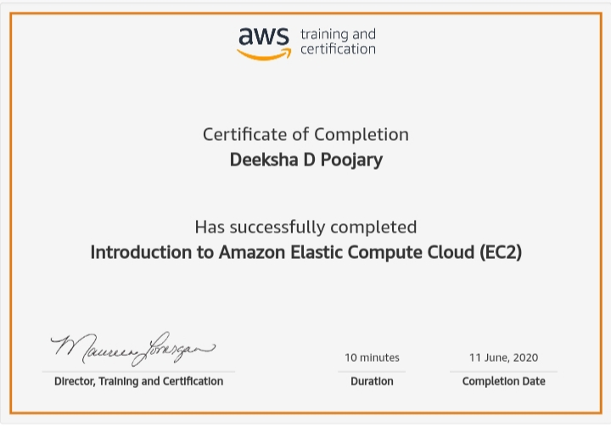Coding Challenges Details:

|  |
| --- |
|  |
|  |
|  |
|  |
|  |
|  |
|  |
|  |
|  |
|  |
|  |
|  |
|  |
|  |
|  |
|  |
|  |
|  |
|  |
|  |
|  |
|  |
|  |
|  |
|  |
|  |
|  |
|  |
|  |
|  |
|  |
|  |
|  |
|  |
|  |
|  |
|  |
|  |
|  |
|  |
|  |
|  |
|  |
|  |
|  |
|  |
|  |
|  |
|  |
|  |
|  |
|  |
|  |
|  |

**Program1:**

**#include <stdio.h>**

**int main()**

**{**

**int n;**

**printf("Enter the values of n: ");**

**scanf("%d",&n);**

**int flag = 0;**

**int mat[n][n];**

**int i, j;**

**printf("Enter the elements:\n");**

**for(i = 0; i < n; i++)**

**{**

**for(j = 0; j < n; j++)**

**scanf("%d",&mat[i][j]);**

**}**

**for (i = 1; i < n; i++)**

**for (j = 0; j < i; j++)**

**if (mat[i][j] != 0)**

**flag = 0;**

**else**

**flag = 1;**

**if (flag == 1)**

**printf("Upper Triangular Matrix\n");**

**else**

**printf("Not an Upper Triangular Matrix\n");**

**return 0;**

**}**